

**MBA SCMS**

**III Semester MBA – Sep 2021**

**Course Title: Data Visualization for Decision Making**  **Course Code:** 20MBAB003

**Duration**: 2 Hours **Date:**

**Time:**  **Max Marks:** 50

**Section – A**

**Short Answer - Answer any 2 Questions out of 3 (2 x 5 = 10)**

1. Explain the use of drill down view in Tableau.
2. Explain following terms: a) Data Source Page b) Dimension c) Calculated Field d) Dashboard e) Marks Card
3. Discuss the “Show Me” feature of Tableau

**Section – B**

**Answer any 2 Questions out of 3 (2 x 10 = 20)**

1. Which visualization(s) is/are ideal for:
   1. Single Numeric variable
   2. Single Numeric variable when we wish to assess if the distribution is normal
   3. Single Numeric variables when we wish to detect outliers
   4. Single Categorical variable when there are 3-4 categories
   5. Single Categorical variable when there are 5 and more categories
   6. Two numeric variables
   7. Two categorical variables
2. Discuss the design flow in Tableau visualization
3. Discuss the application of sheets, dashboard and story in Tableau.

**Section – C**

**Case Study: 2 Questions Compulsory (2 x 10 = 20)**

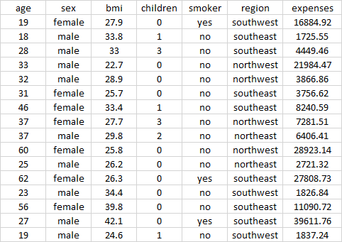

1. Describe the data in terms of measures and dimensions.
2. Suggest some useful visualizations out of this data mentioning the fields.